WhatsApp Business Number Integration with AMANDA [Task 239: SMS register with IMDA](https://azuredevops.attsystemsgroup.com/PROJECT_COLLECTIONS/Mobility_AMANDA-PUB/_queries/edit/239/?triage=true)

1. Meta Business: Create Meta Business Profile (or) use the existing verified business profile with website url and business email mentioned
2. Meta Business: Add WhatsApp accounts in this business portfolio as follows. That number should not be used in any WhatsApp account. (Fig 2 section)
3. Twilio: Create Account
4. Twilio: Upgrade Account to link up Payment method to be able to use BYON

Create Messaging > Senders > WhatsApp Sender with BYON (Direct Brand or Independent Software Vendor) base on your choice , have to upload documents to get WhatsApp Sender with own number

1. Twilio: Link with Meta Business Profile

Fig2-1

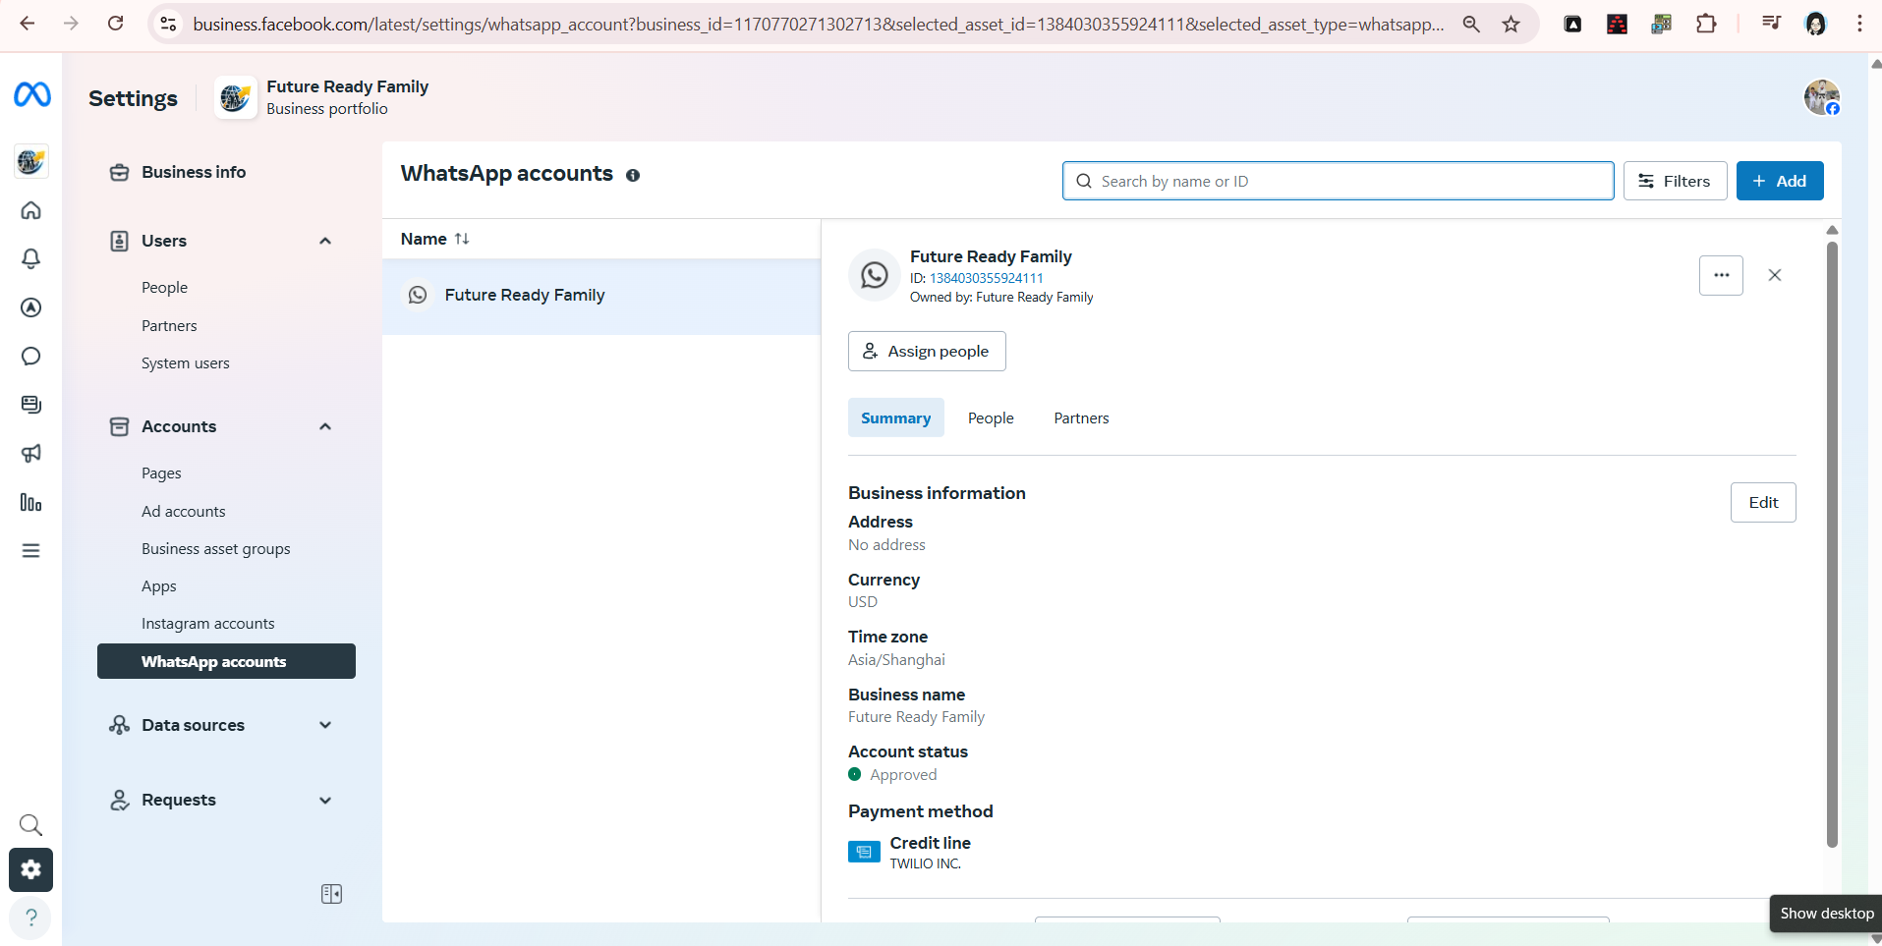

+Add Fig2-2

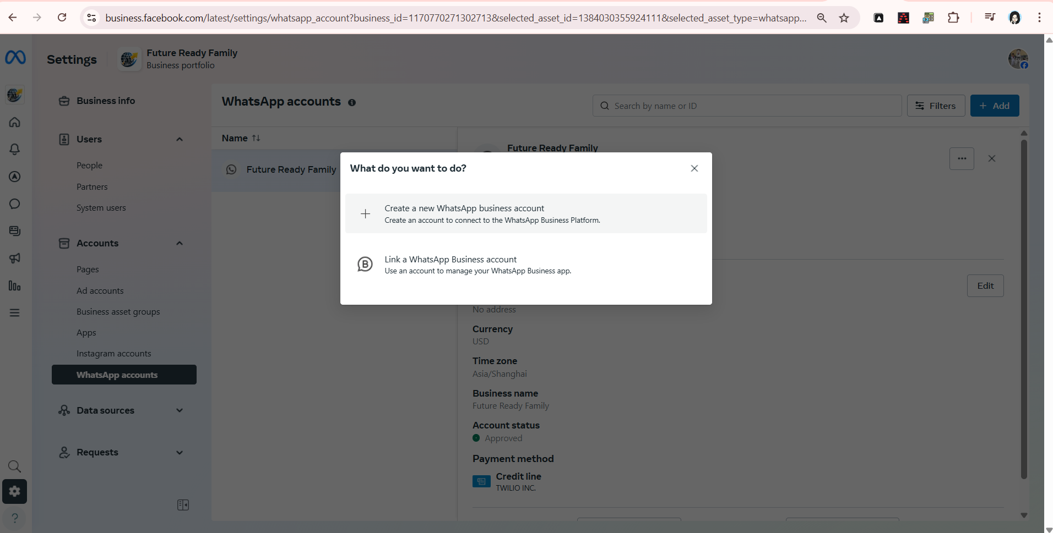  
Fig2-3

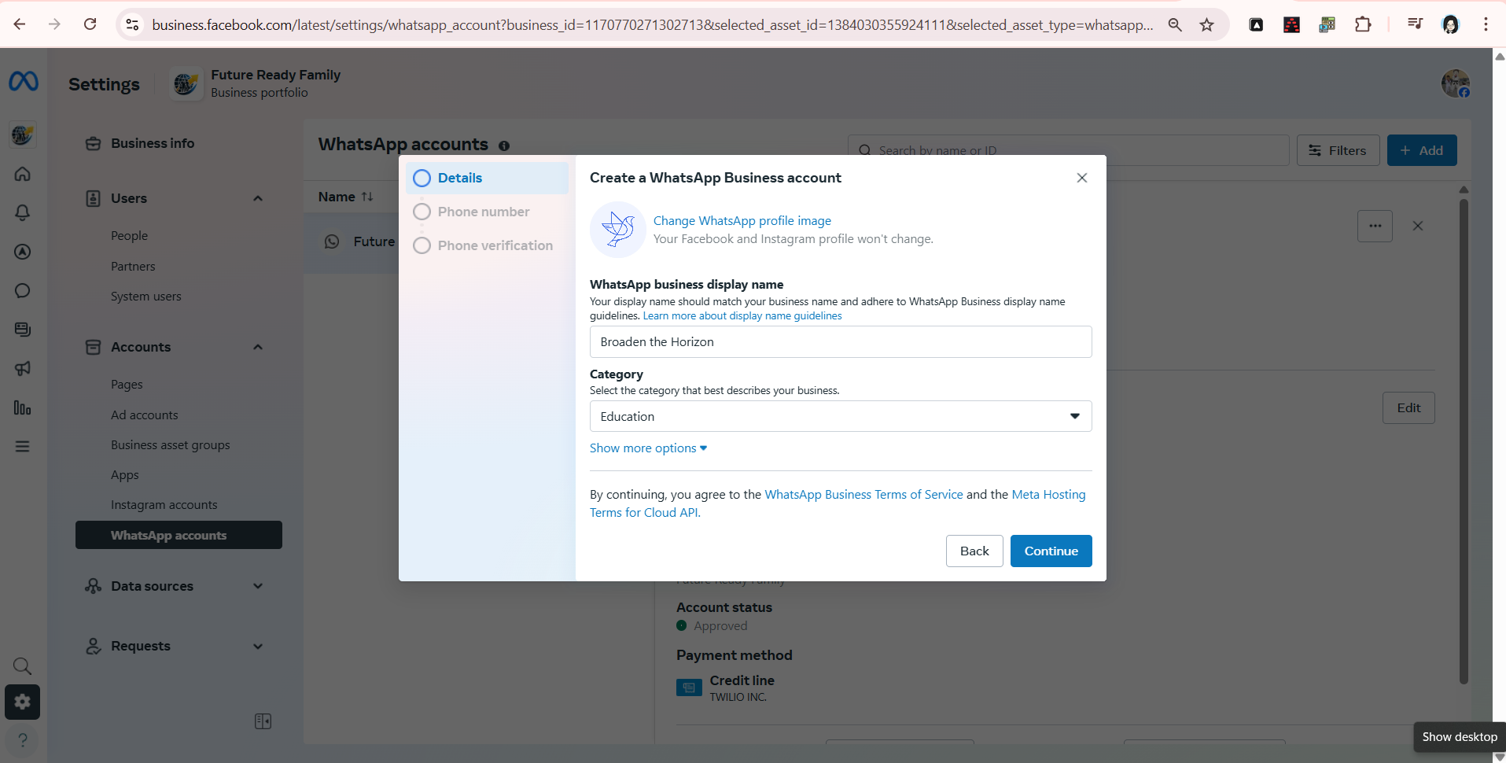  
  
Fig2-4

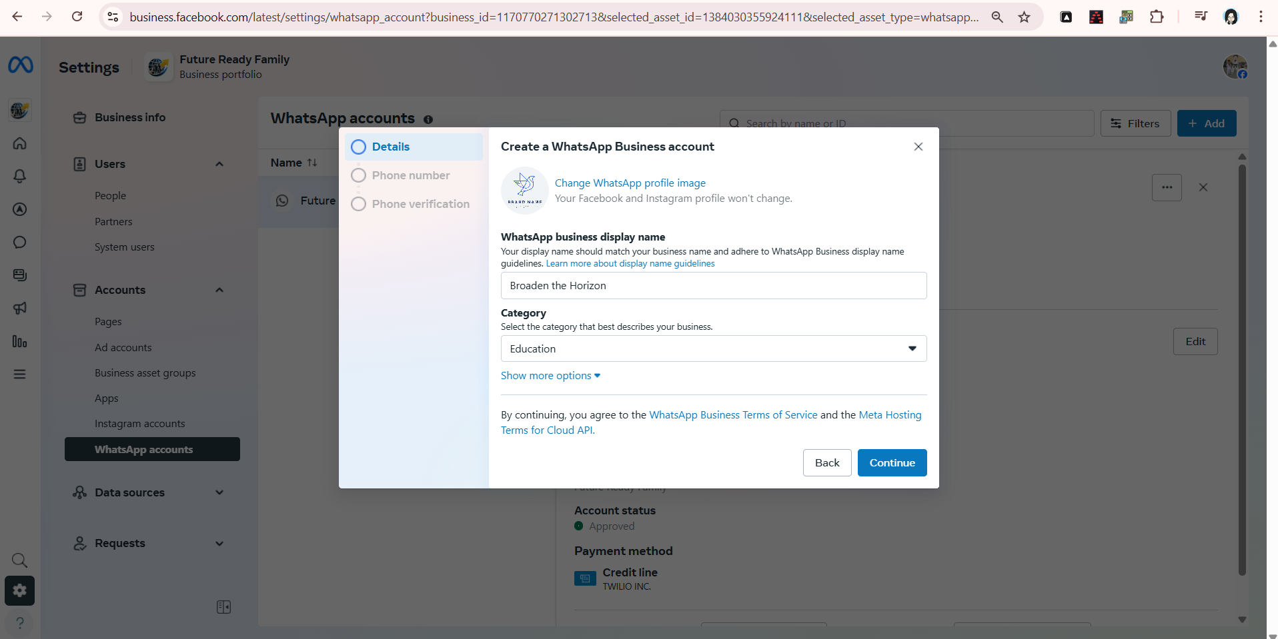  
Fig 2-6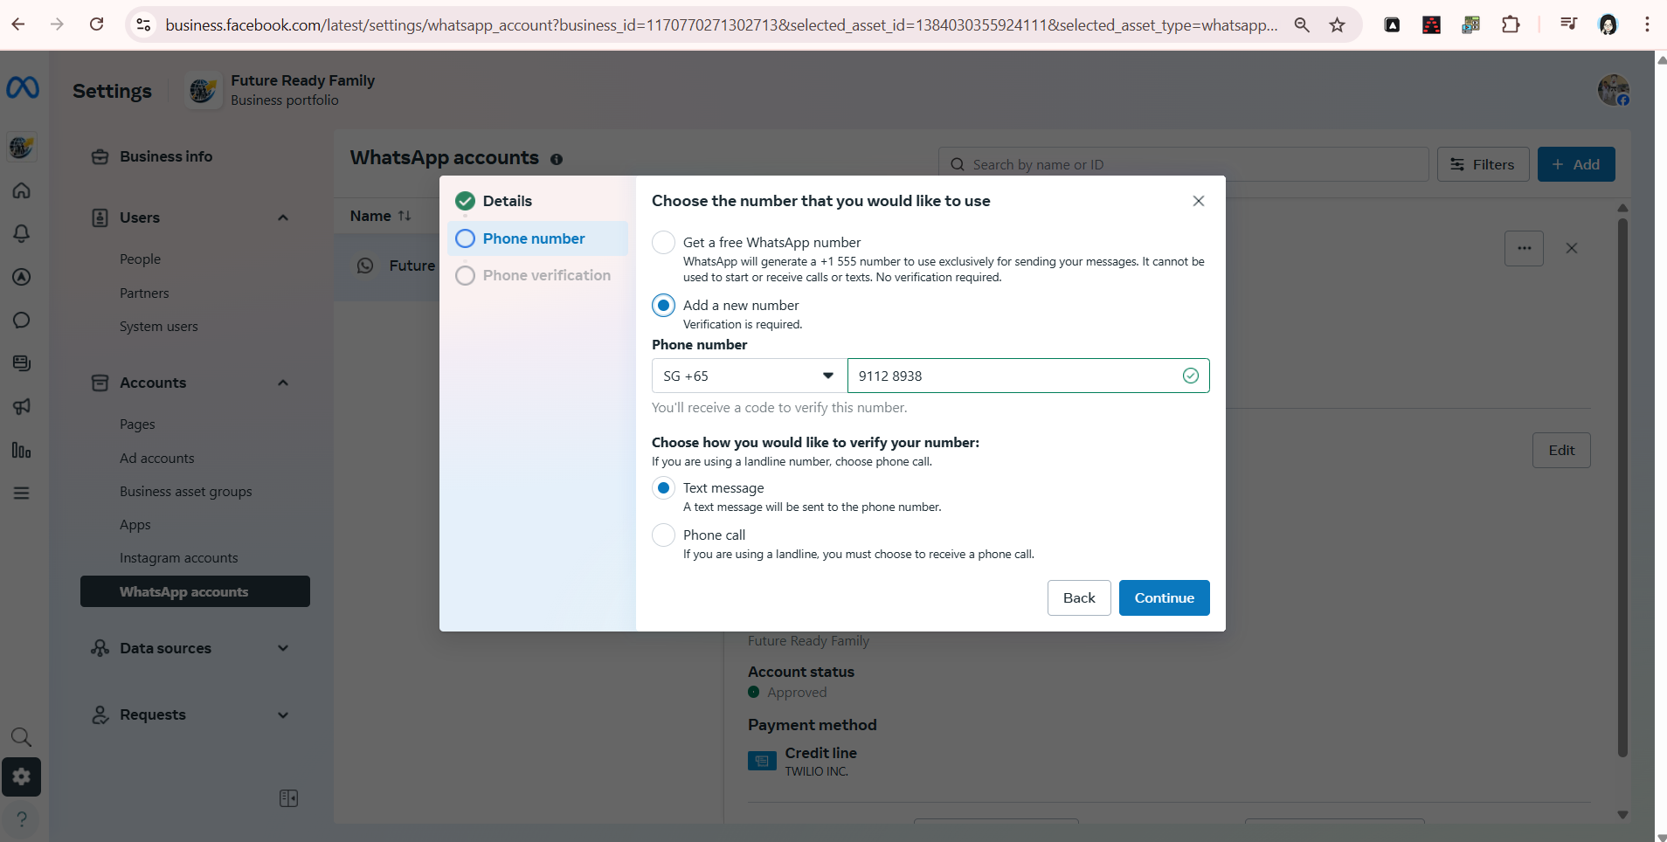

Put OTP to confirm and then finished

Fig 2-7 (There is no payment method linked with WhatsApp Business Account)

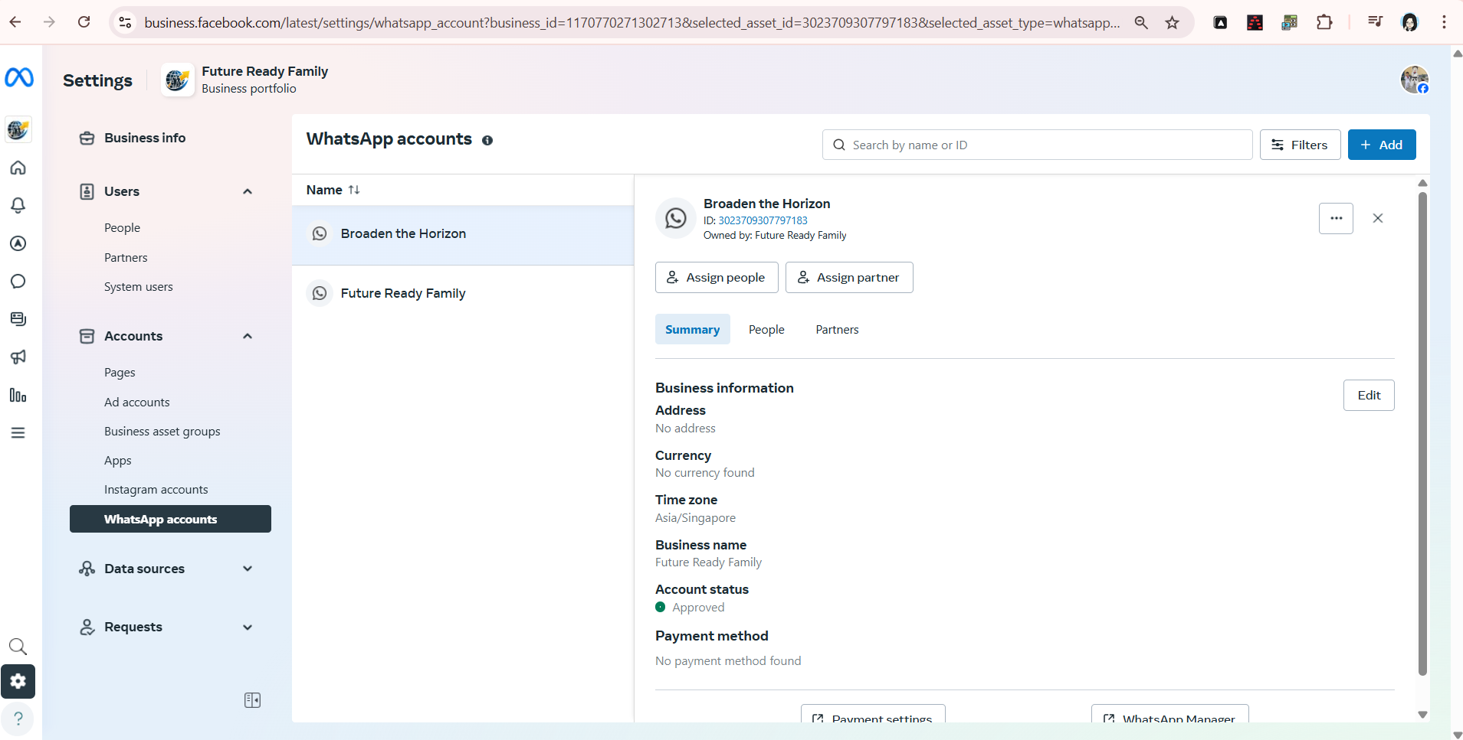

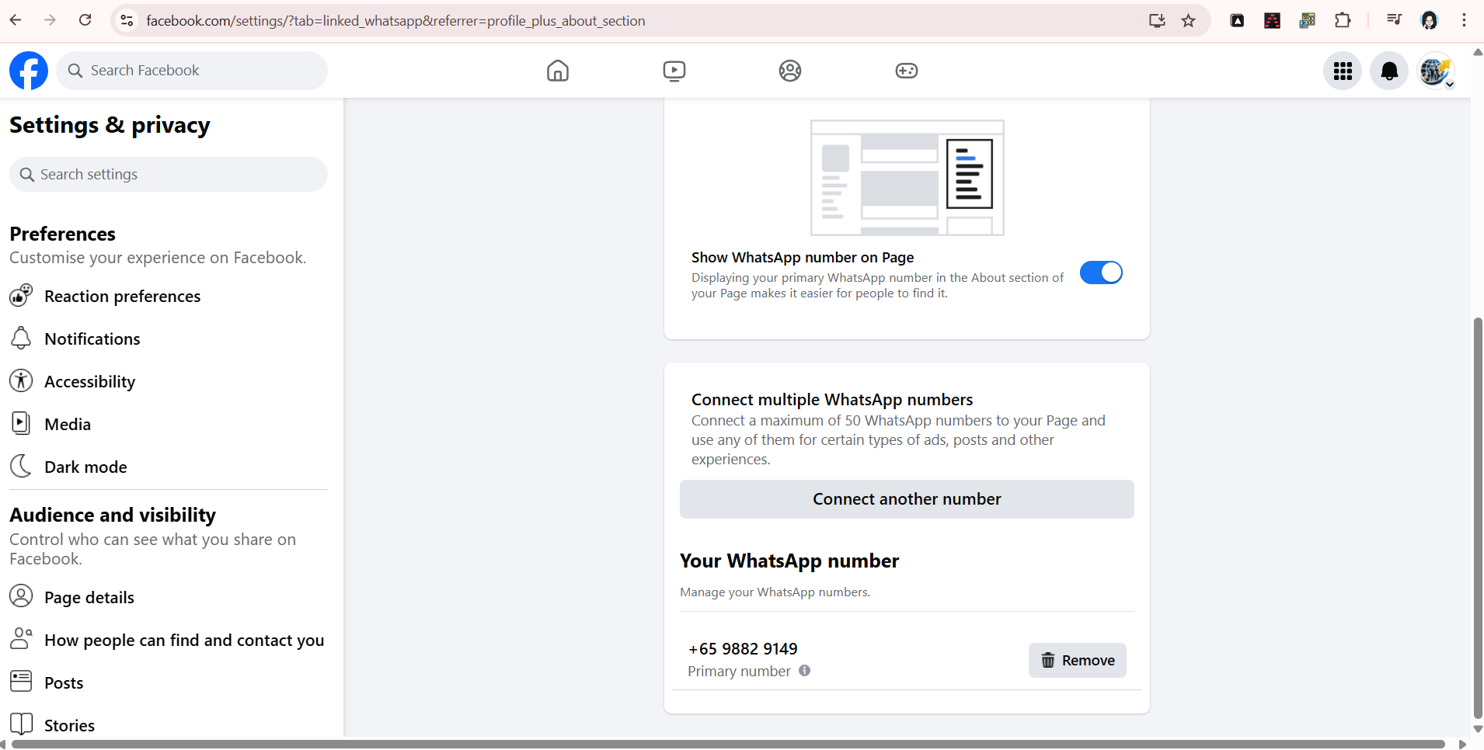

Fig 4-1

To use Twilio (BYON) WhatsApp , Upgrade the account type able to use BYON

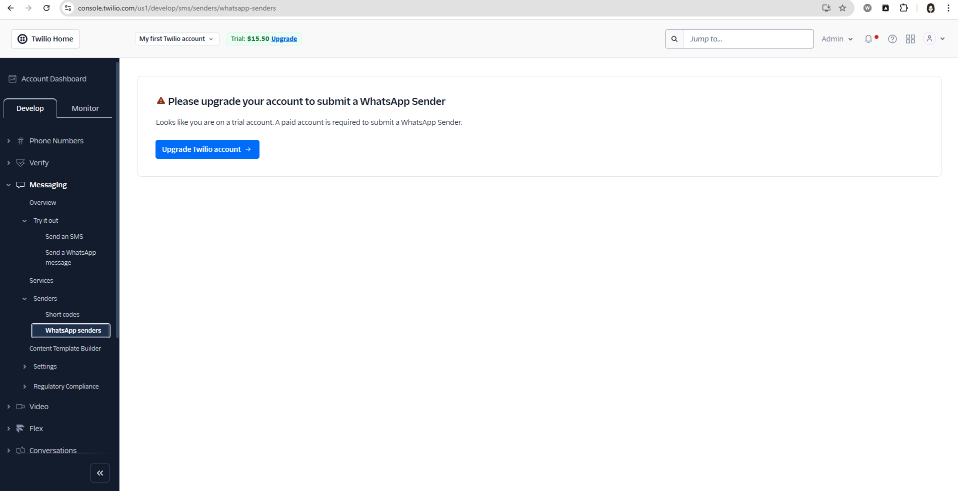

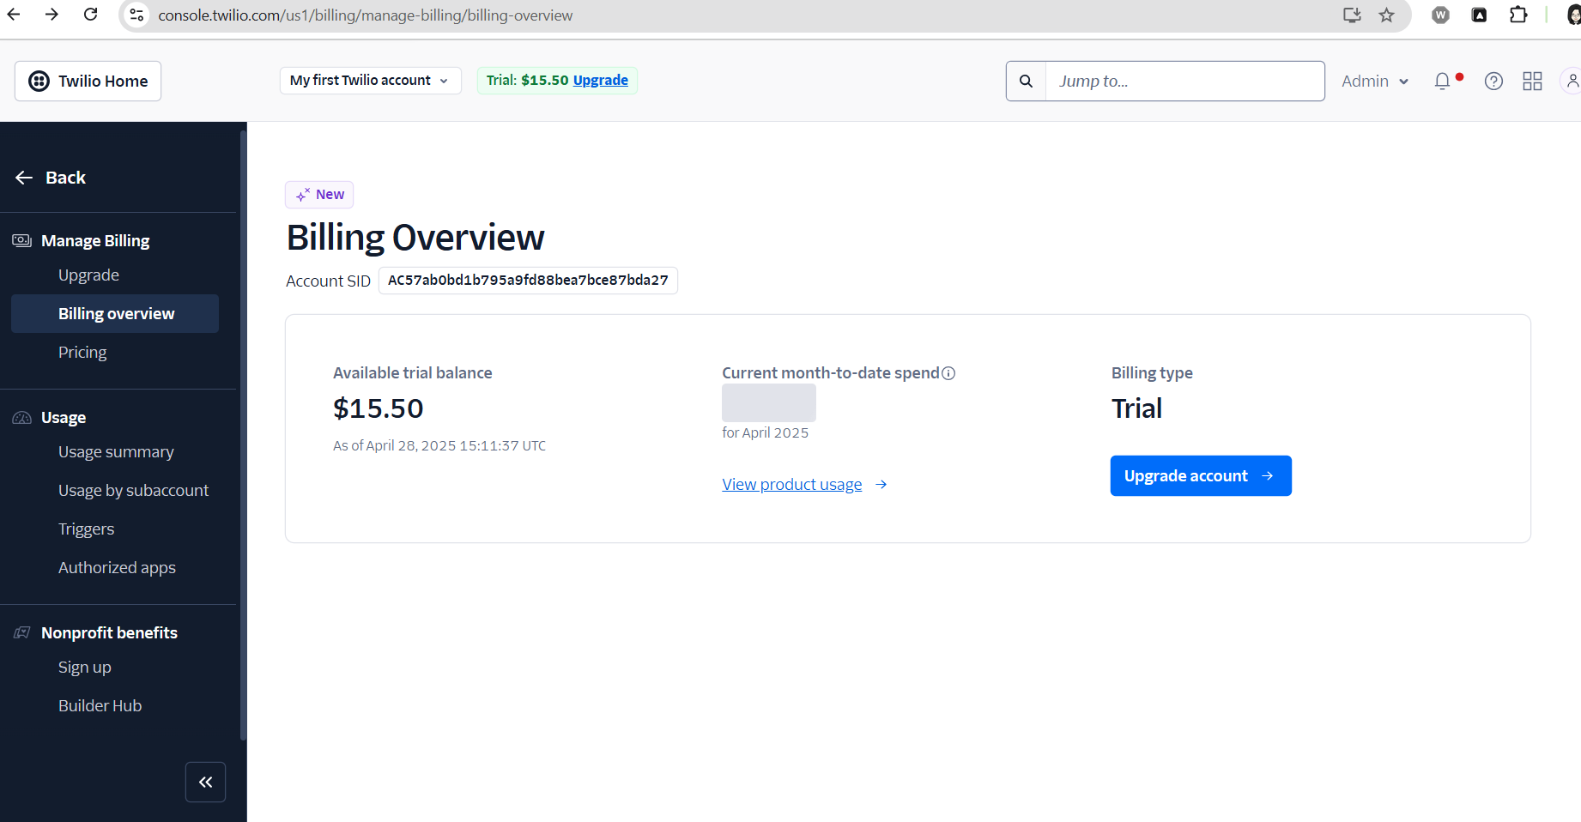

Fig 4-2

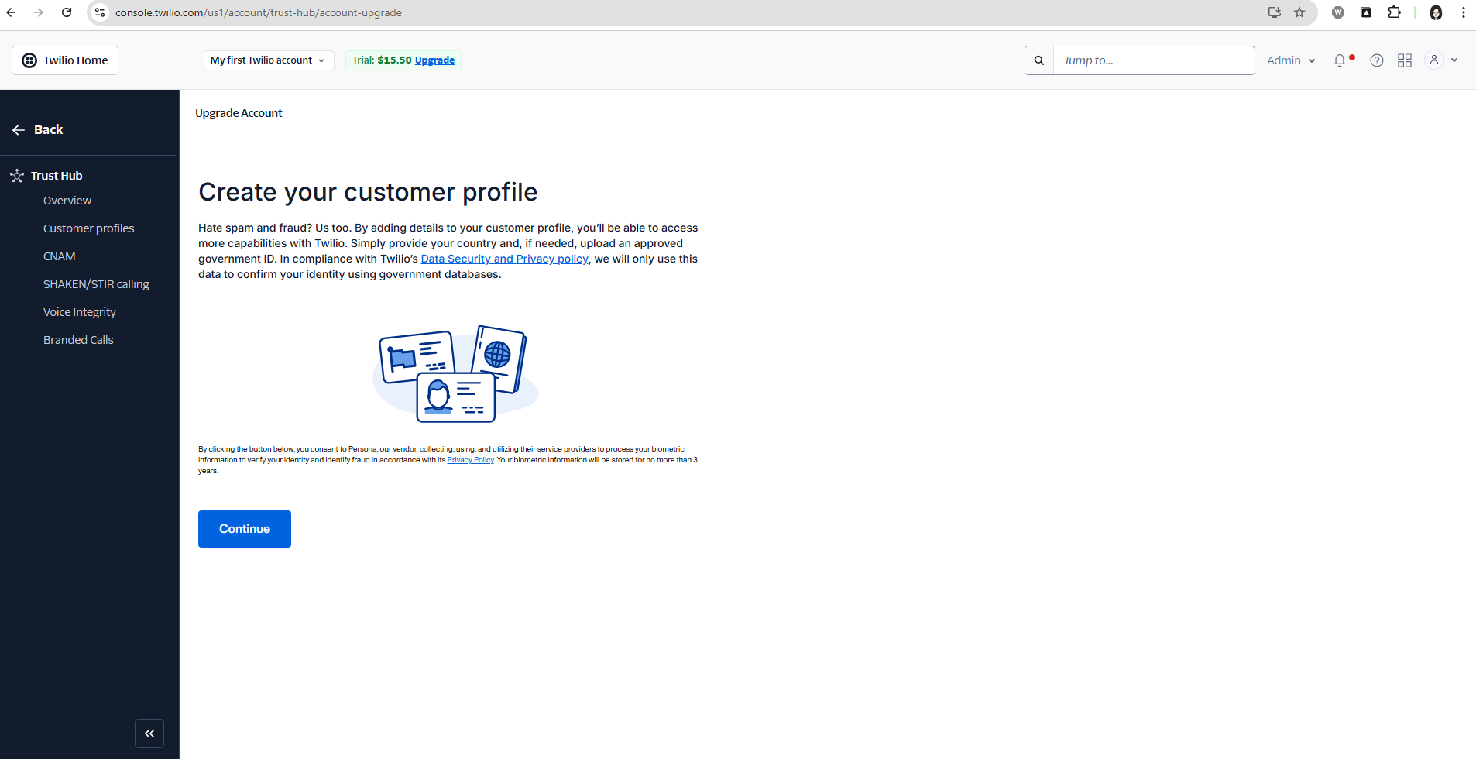

Fig 4-3

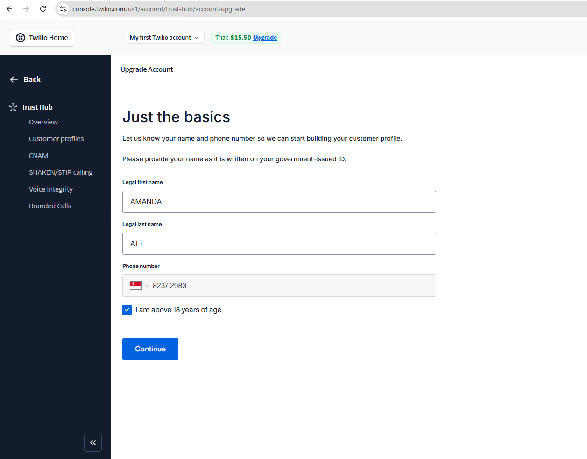

Fig 4-5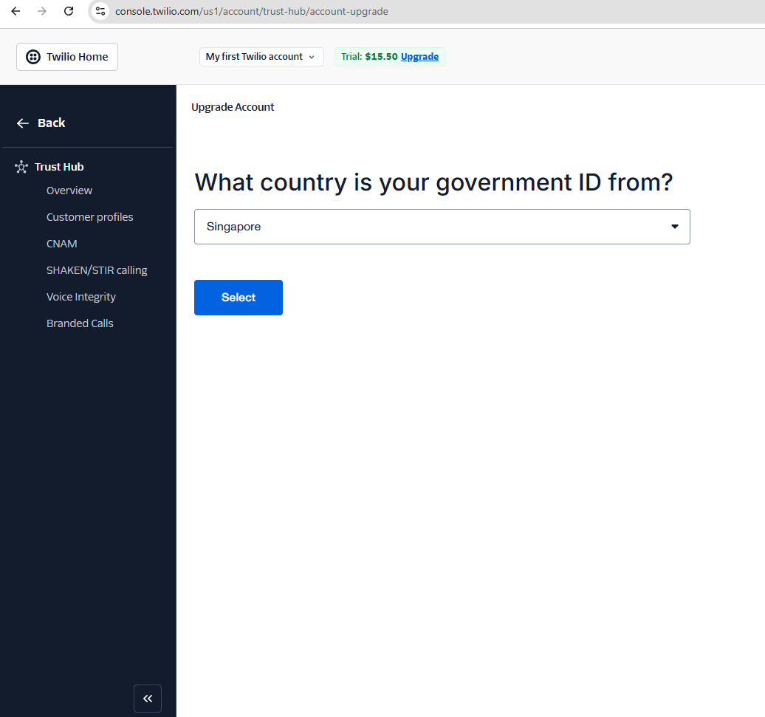

Fig 4-6

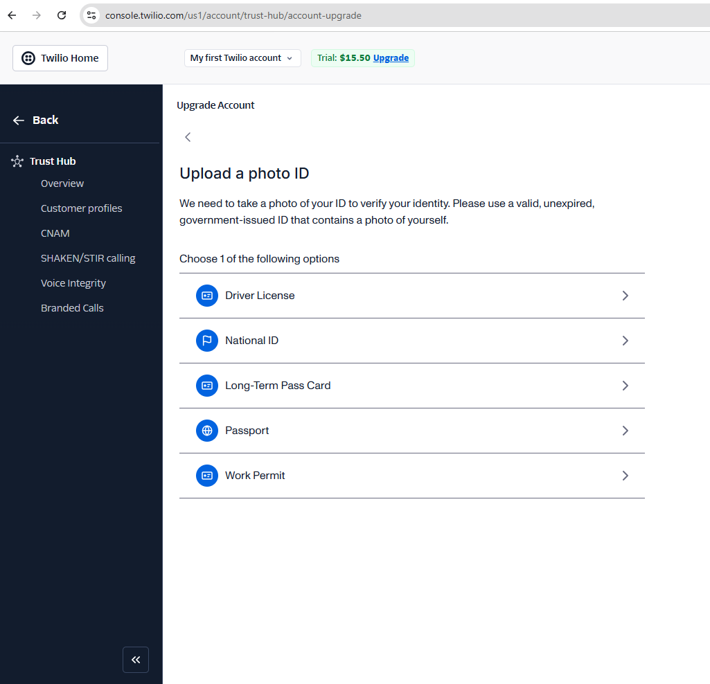

///////

Can hide/display WhatsApp Number on page

